* **Design Methodology**

I started my VGA controller project with counting the pixels on screen first horizontally and when a row is done, I passed new row in downwards until every row is done. While counting I determine the pixel locations according to screens resolution which means its horizontal and vertical porches and sync pulses, so pixel locations will be in the active (displayed) screen. After I mapped out the screen, only thing remained was the color of the screen and its attachment to switches, so I assign total 12 switches which goes like 4 switches to red, 4 switches to green, 4 switches to blue. I have also assigned a button for disabling the view, simply turning off the VGA port output.

- In my preliminary lab report I stated that I want to make the initial color of the screen white. At first, I thought because at the beginning switches are ‘0’ it made output conflicts but afterwards I got the idea that using switches as inverted way. After inverted them, it worked as I planned.

**-** As I worked on my project and learnt VGA more my modules and especially my design has been changed compared to my preliminary lab report.

* **Results**

**RTL Schematic**

Like it is seen in the figure above my idea at the preliminary report was substantially right but I need to make some changes in the modules and their designs.

**Sync module**

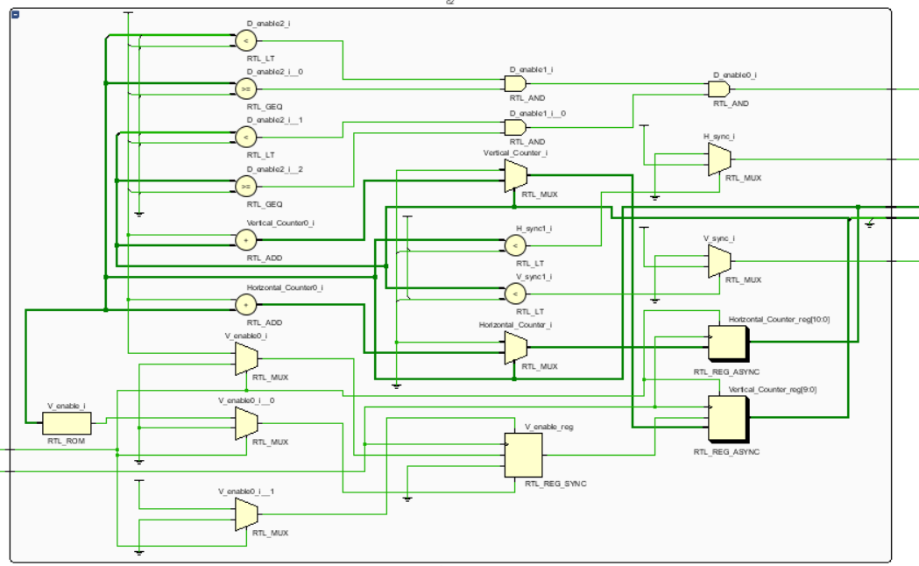

**Paint module**

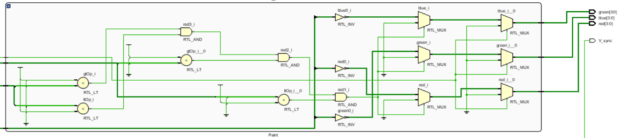

* **Screen shot of the display and Basys3**

Because I want to obtain white screen at opening, I used switches as inverted. Most significant 4 switches assigned for red, 4 center switches for assigned green and least significant 4 switches for assigned blue.

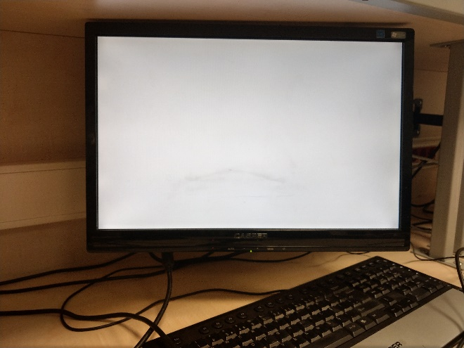 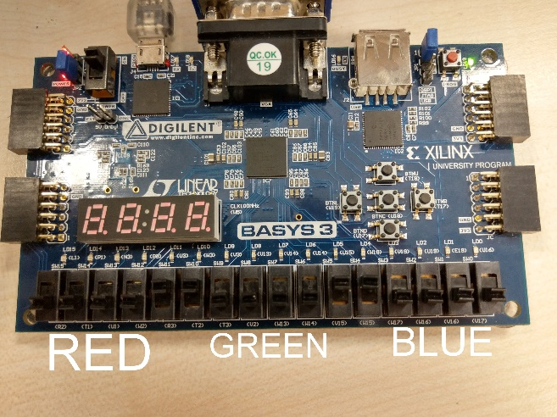

Red = “1111”, Green = “1111”, Blue = “1111”

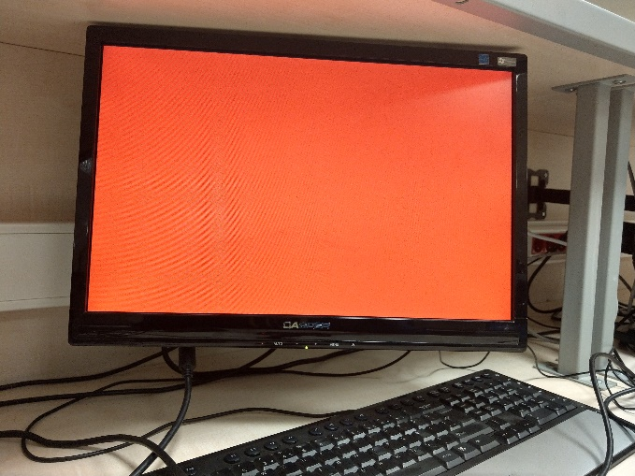 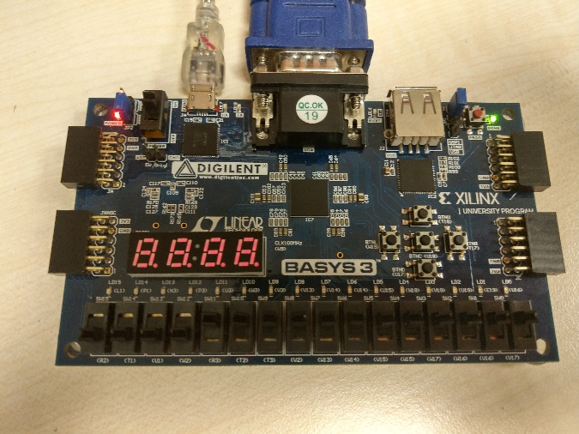

Red = “1111”, Green = “0000”, Blue = “0000”

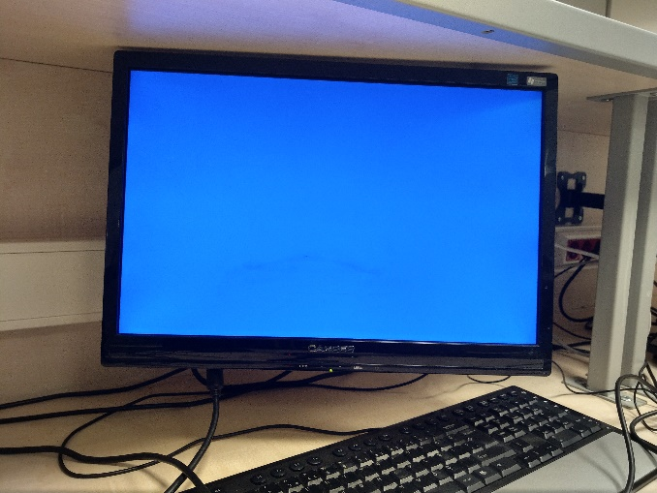 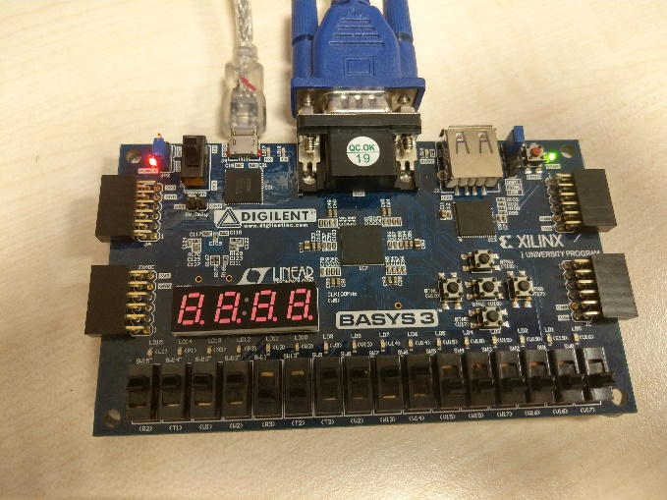

Red = “0000”, Green = “0000”, Blue = “1111”

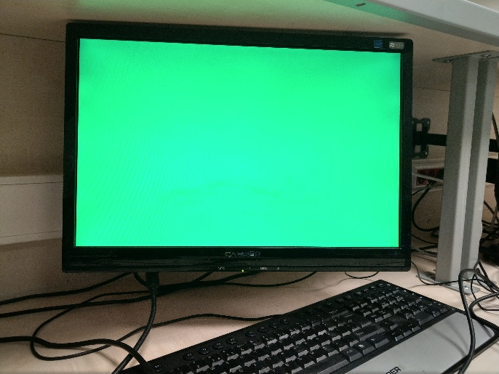 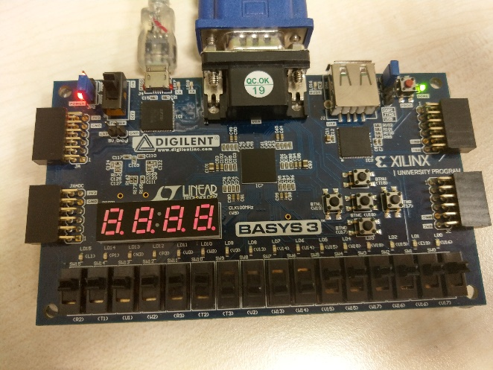

Red = “0000”, Green = “1111”, Blue = “0000”

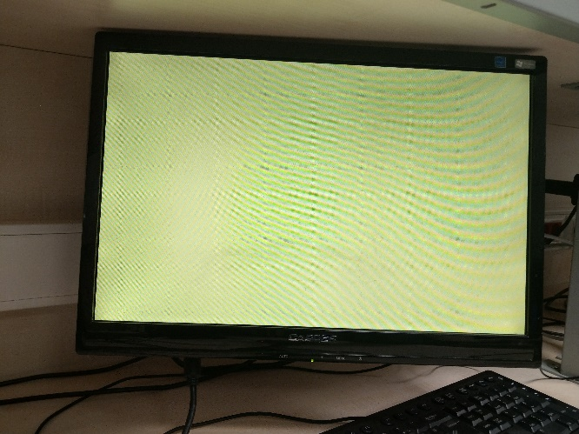 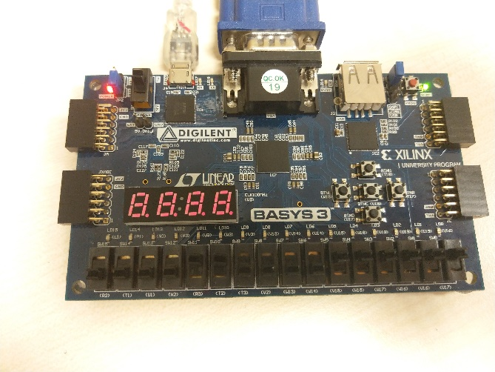

Red = “1111”, Green = “1111”, Blue = “0000”

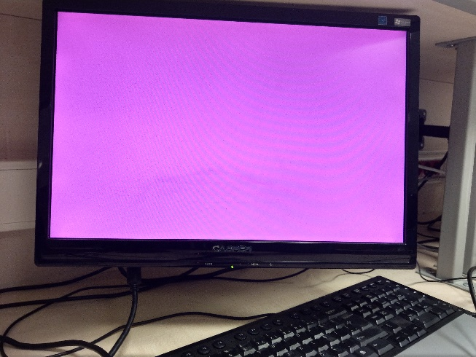 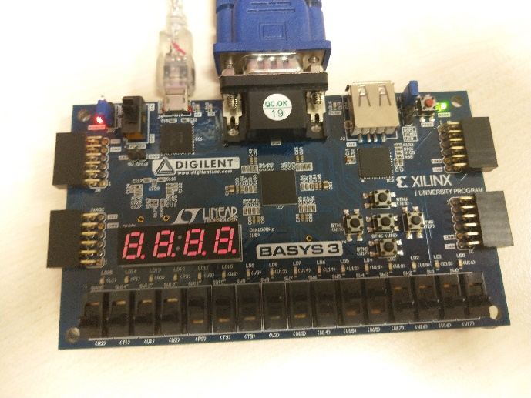

Red = “1111”, Green = “0000”, Blue = “1111”

* **Conculusion**

At first I was thinking take the resolution as 1280x1024 and I did, but I did not obtain what I expected for display, it was like 2/3 part of the screen was active and rest was black and I could not change it no matter what I did with those spects, I searched on internet about spects of the screen I used and I found that it was 1440x900. It is a rare resoulution actually. I change my code respect to those spects and afterward I finally got what I wanted from the display.

* **Appendices**

**Top Module:**

library IEEE;

use IEEE.STD_LOGIC_1164.ALL;

entity Top_Module is

Port ( clk : in std_logic;

clear_btn : in std_logic;

Switches : in std_logic_vector(11 downto 0);

H_sync : out std_logic;

V_sync : out std_logic;

red : out std_logic_vector(3 downto 0);

green : out std_logic_vector(3 downto 0);

blue : out std_logic_vector(3 downto 0));

end Top_Module;

architecture Behavioral of Top_Module is

component Synch is

Port ( clk100Mhz : in std_logic;

clear : in std_logic;

H_sync : out std_logic;

V_sync : out std_logic;

D_enable : out std_logic;

Location_H : out std_logic_vector(10 downto 0);

Location_V : out std_logic_vector(10 downto 0));

end component;

component Paint is

Port (D_enable : in std_logic;

Location_H : in std_logic_vector(10 downto 0);

Location_V : in std_logic_vector(10 downto 0);

Switches : in std_logic_vector(11 downto 0);

red : out std_logic_vector(3 downto 0);

blue : out std_logic_vector(3 downto 0);

green : out std_logic_vector(3 downto 0));

end component;

signal D_enable : std_logic;

signal clr : std_logic;

signal Location_H : std_logic_vector(10 downto 0);

signal Location_V : std_logic_vector(10 downto 0);

begin

clr <= clear_btn;

c2 : Synch port map(clk, clr, H_sync, V_sync, D_enable, Location_H, Location_V);

c3 : Paint port map( D_enable, Location_H, Location_V,Switches, red, green, blue);

end Behavioral;

**Sync:**

library IEEE;

use IEEE.STD_LOGIC_1164.ALL;

use IEEE.STD_LOGIC_UNSIGNED.ALL;

use IEEE.STD_LOGIC_ARITH.ALL;

entity Synch is

Port ( clk100Mhz : in std_logic;

clear : in std_logic;

D_enable : out std_logic;

Location_H : out std_logic_vector(10 downto 0);

Location_V : out std_logic_vector(10 downto 0);

H_sync : out std_logic;

V_sync : out std_logic);

end Synch;

architecture Behavioral of Synch is

constant Pixels_H : integer := 1904;

constant Pixels_V : integer := 932;

constant hf_porch : integer := 1824;

constant vf_porch : integer := 931;

constant hb_porch : integer := 232;

constant vb_porch : integer := 28;

constant hs_pulse : integer := 152;

constant vs_pulse : integer := 3;

signal V_enable : std_logic;

signal Horizontal_Counter : integer range 0 to 1904;

signal Vertical_Counter : integer range 0 to 932;

begin

process(clk100Mhz, clear)

begin

if clear = '1' then

Horizontal_Counter <= 0;

elsif(clk100Mhz'event and clk100Mhz = '1') then

if Horizontal_Counter = Pixels_H - 1 then

Horizontal_Counter <= 0;

V_enable <= '1';

else

Horizontal_Counter <= Horizontal_Counter + 1;

V_enable <= '0';

end if;

end if;

end process;

H_sync <= '0' when Horizontal_Counter < 112 else '1';

process(clk100Mhz, clear)

begin

if clear = '1' then

Vertical_Counter <= 0;

elsif(clk100Mhz'event and clk100Mhz = '1' and V_enable = '1') then

if Vertical_Counter = Pixels_V - 1 then

Vertical_Counter <= 0;

else

Vertical_Counter <= Vertical_Counter + 1;

end if;

end if;

end process;

V_sync <= '0' when Vertical_Counter < 3 else '1';

D_enable <= '1' when (((Horizontal_Counter < hf_porch) and (Horizontal_Counter >= (hb_porch + hs_pulse))) and ((Vertical_Counter < vf_porch) and (Vertical_Counter >= (vb_porch + vs_pulse)))) else '0';

Location_H <= conv_std_logic_vector(Horizontal_Counter, 11);

Location_V <= conv_std_logic_vector(Vertical_Counter, 11);

end Behavioral;

**Paint**

library IEEE;

use IEEE.STD_LOGIC_1164.ALL;

use IEEE.STD_LOGIC_UNSIGNED.ALL;

entity Paint is

Port (D_enable : in std_logic;

Location_H : in std_logic_vector(10 downto 0);

Location_V : in std_logic_vector(10 downto 0);

Switches : in std_logic_vector(11 downto 0);

red : out std_logic_vector(3 downto 0);

blue : out std_logic_vector(3 downto 0);

green : out std_logic_vector(3 downto 0));

end Paint;

architecture Behavioral of Paint is

begin

process(D_enable,Location_H,Location_V)

begin

red <= "0000";

blue <= "0000";

green <= "0000";

if D_enable = '1' then

if Location_V > 30 and Location_V < 932 and Location_H > 384 and Location_H < 1904 then

red <= not Switches(11 downto 8);

green <= not Switches(7 downto 4);

blue <= not Switches(3 downto 0);

end if;

end if;

end process;

end Behavioral;